# **Transmission Impairments**

Impairments 🡪 குறைபாடுகள்

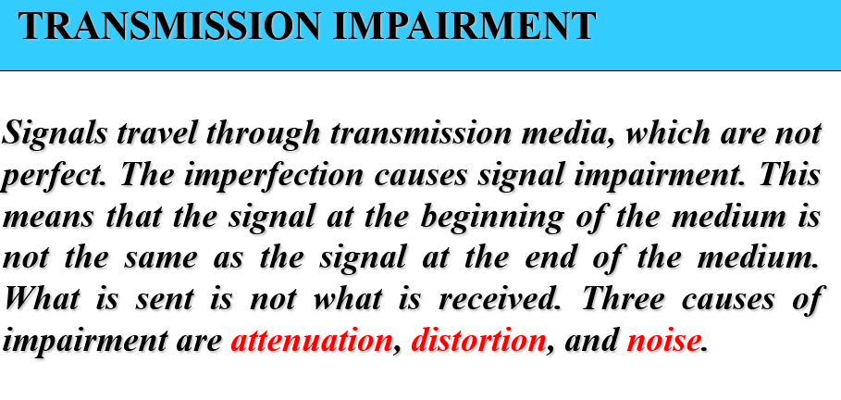  
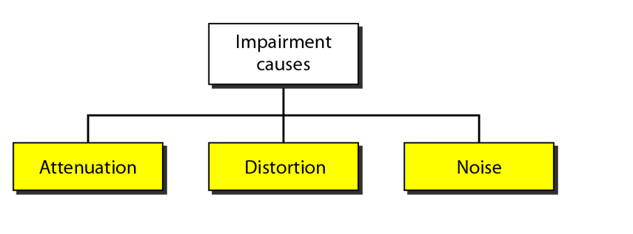

## **Attenuation**

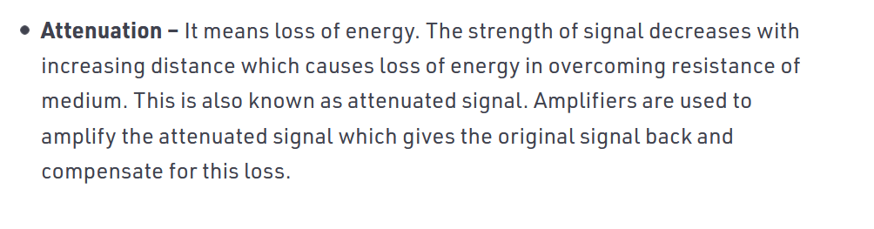 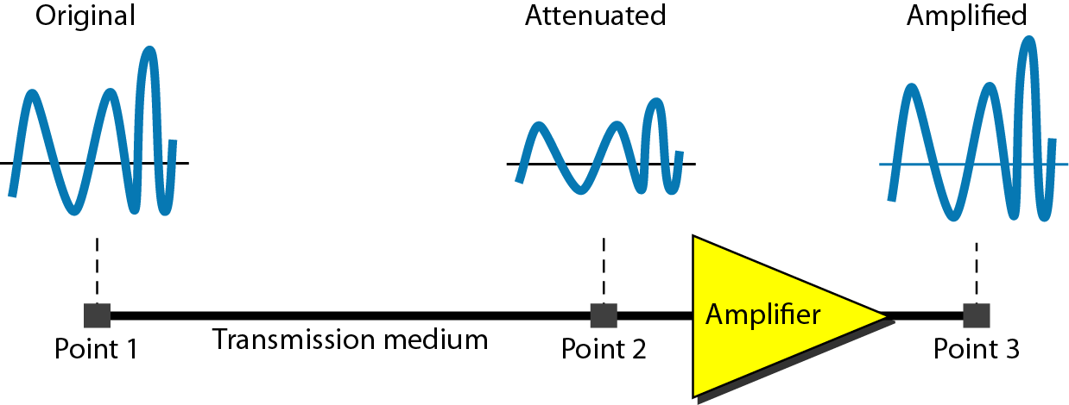

Amplifier 🡪 1) eliminate the noise(or the noise will also be amplified)

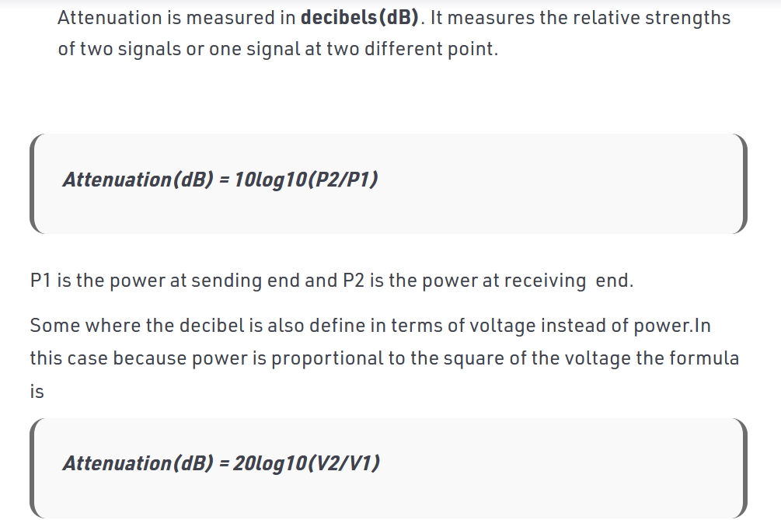

### **Problems**

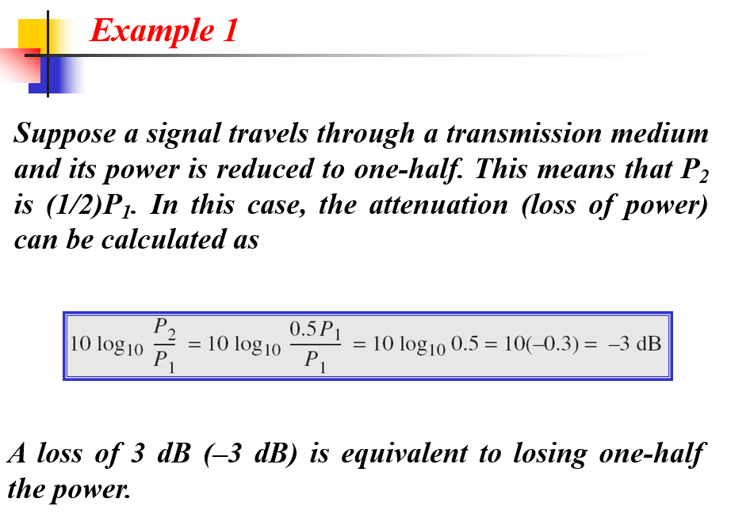

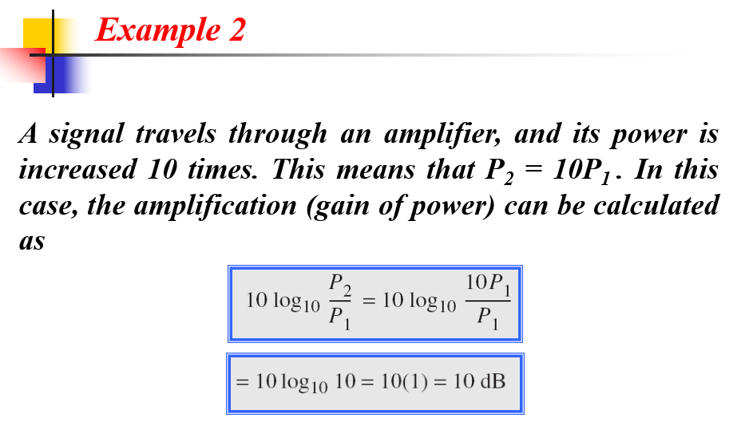

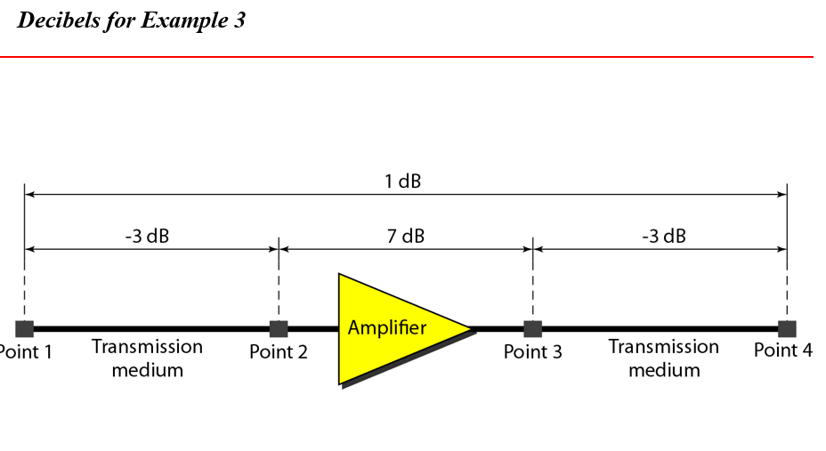  
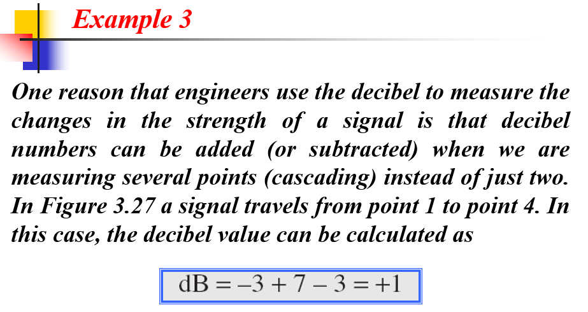



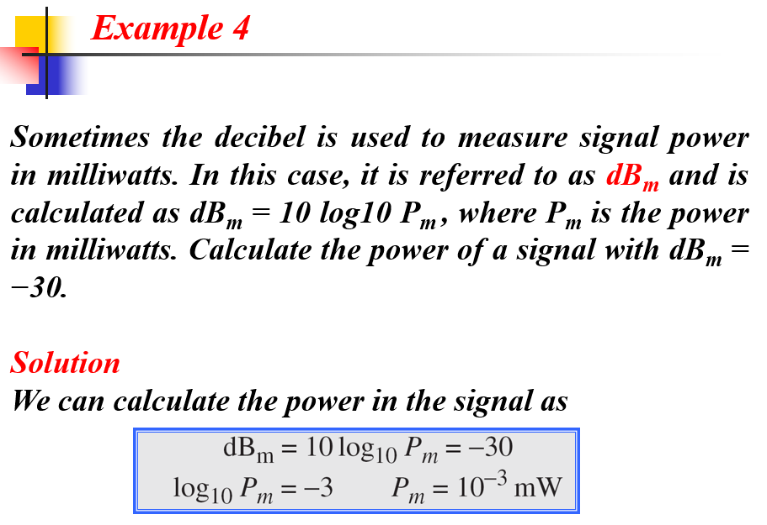

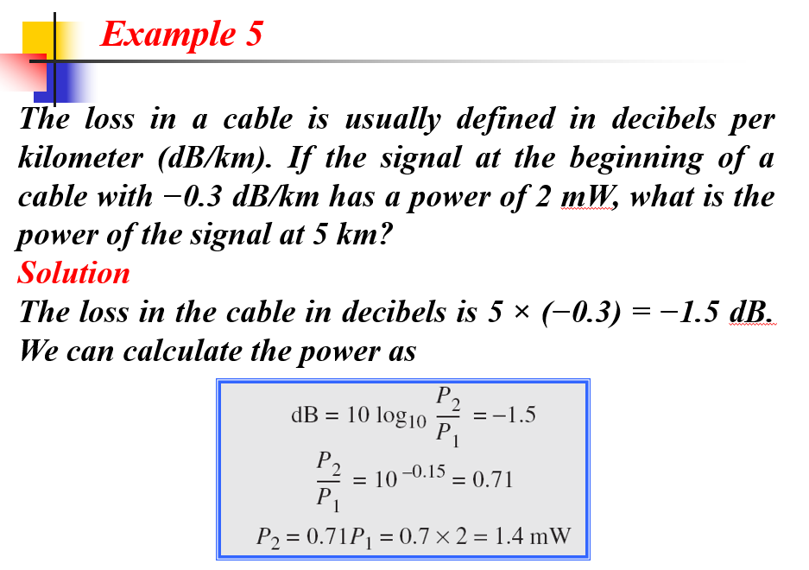

## **Distortion**

Composite Signal 🡪 A composite signal is a combination of two or more simple sine waves with different frequency, phase and amplitude.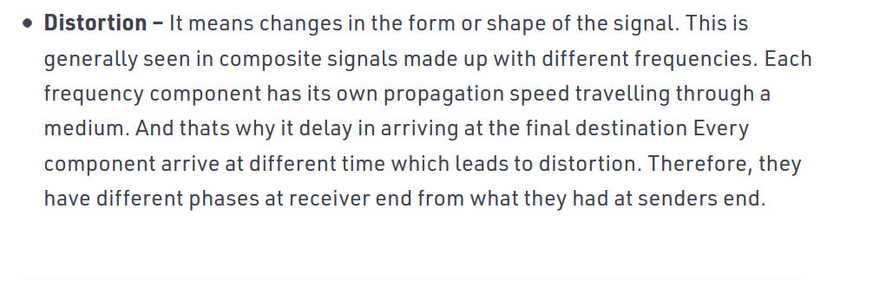  
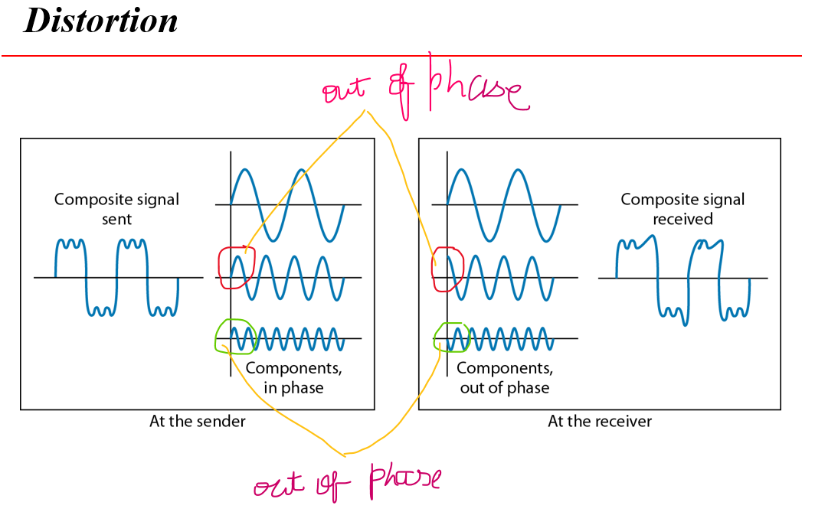

## **Noise**

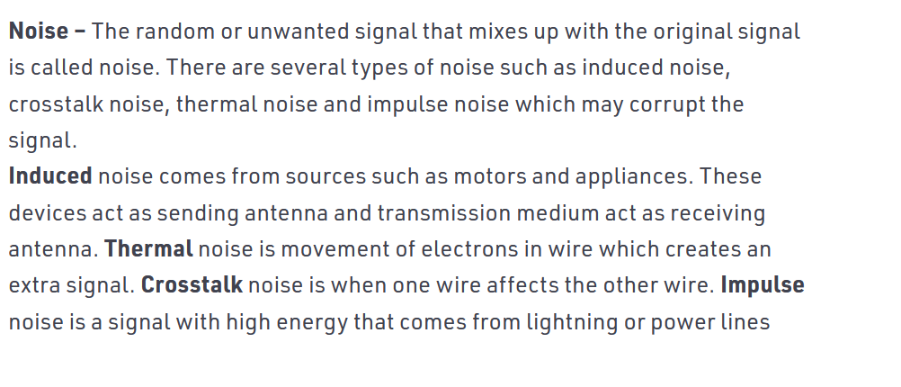

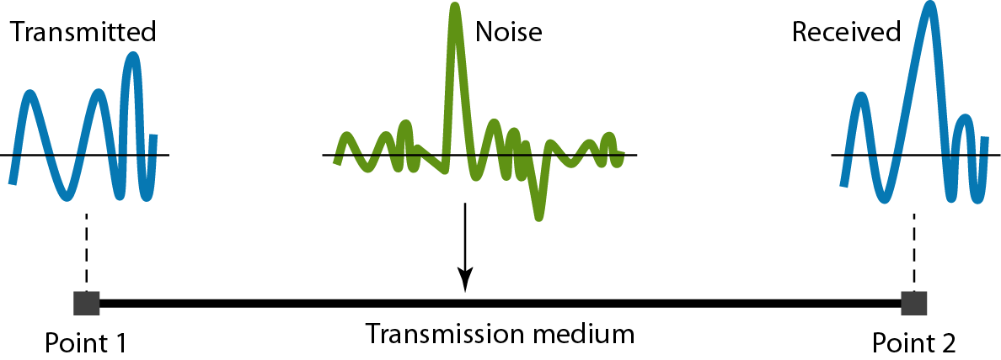

### **Signal to Noise ratio**

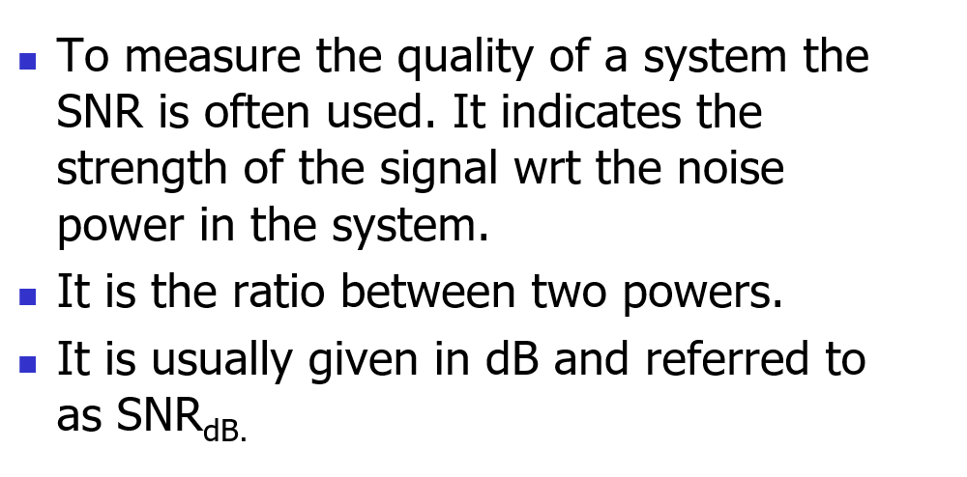

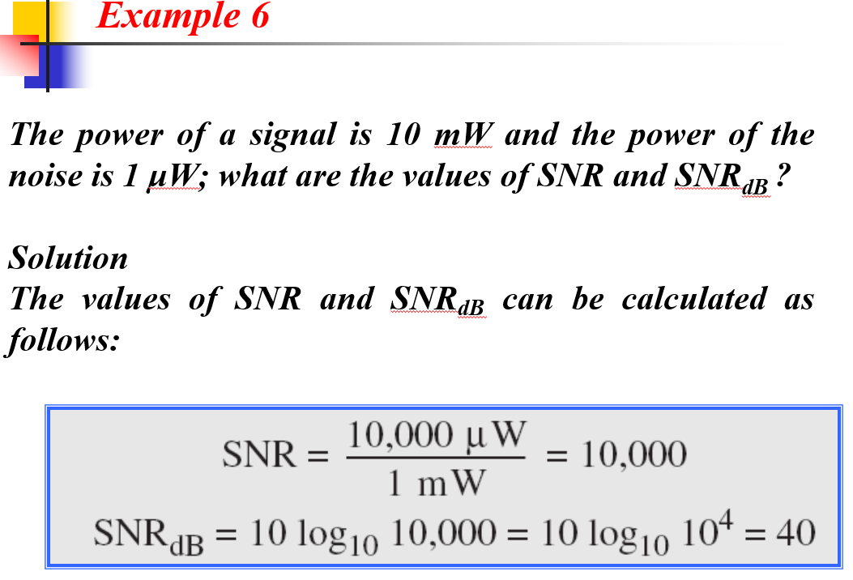

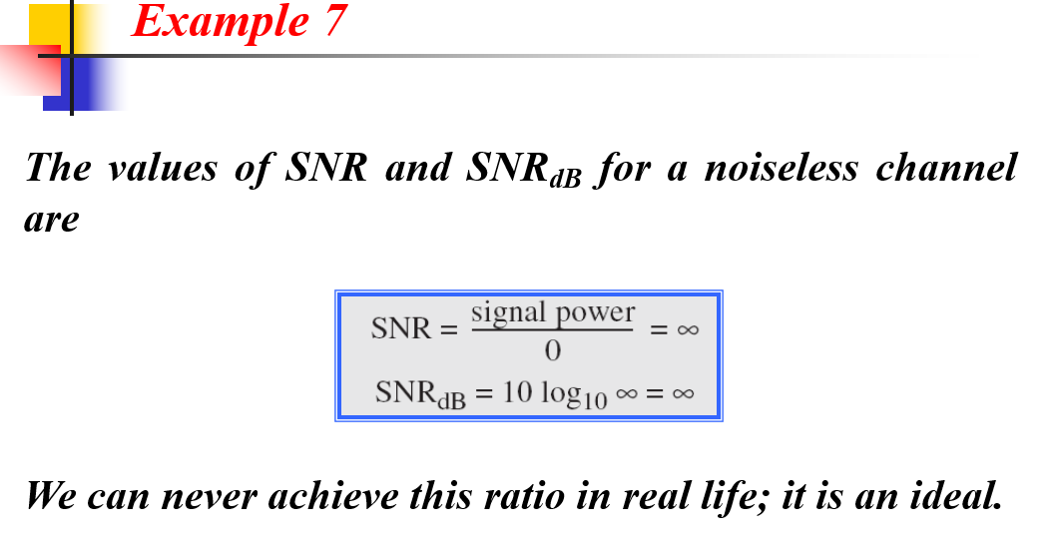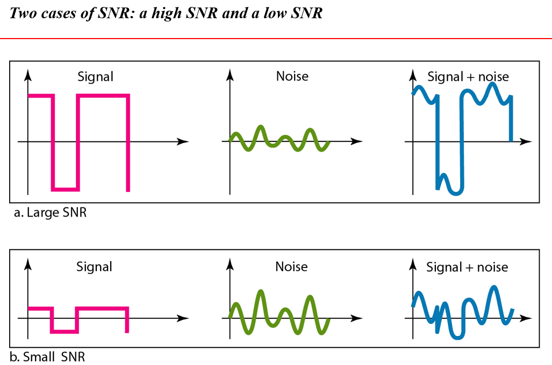

## **Transmission medium and physical layer**

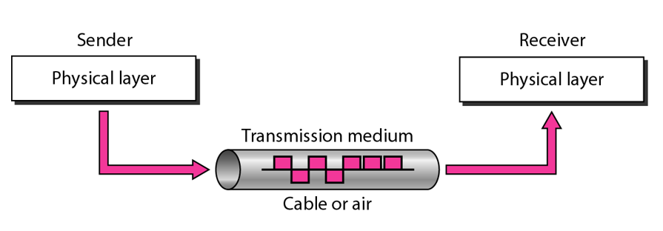  
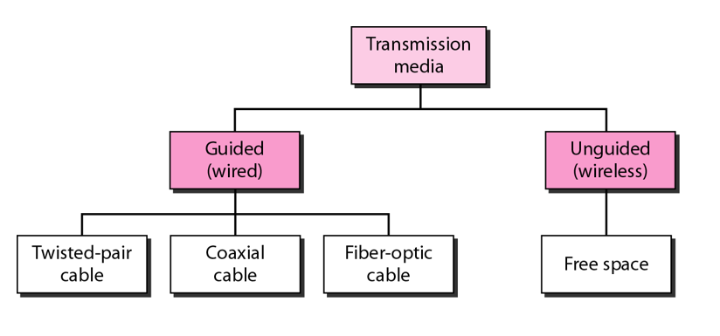

### **Guided Media (wired)**

**Conduit** 🡪 வழியாகச்

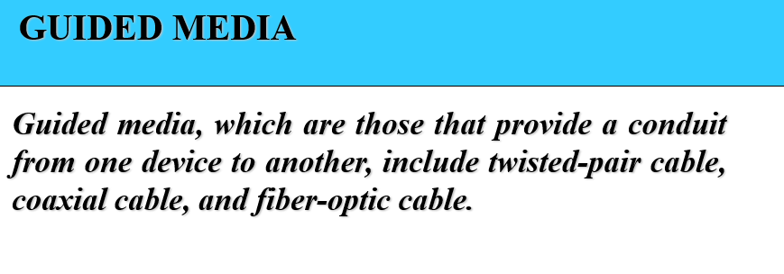

#### **Twisted pair cable**

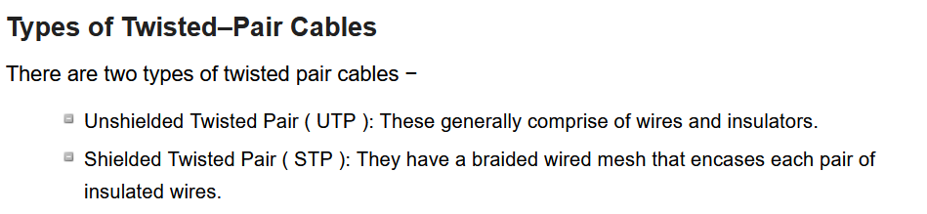

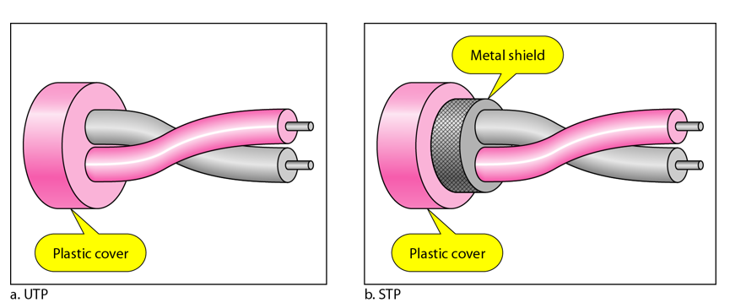

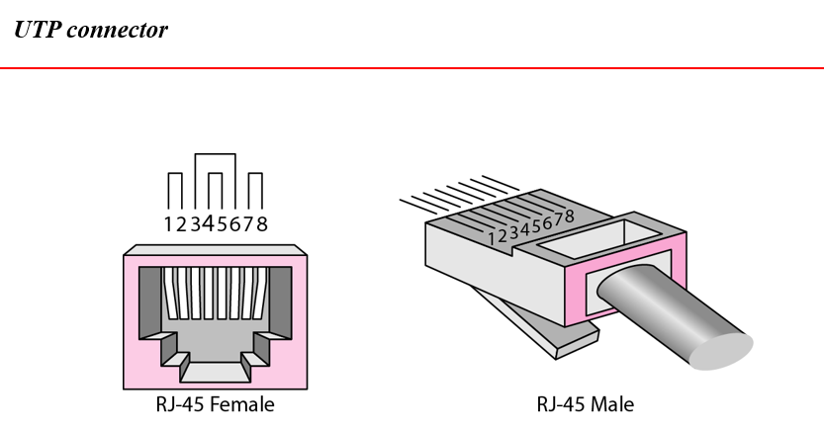

#### **Co-axial cable**

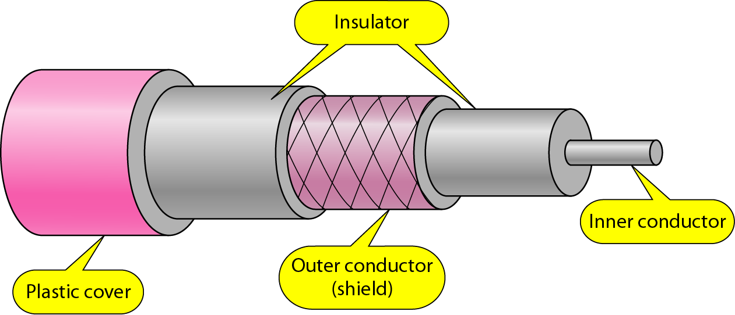

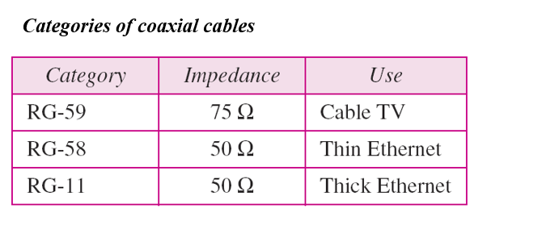

Based on impedance 🡪 the end signal will be terminated.

Application of co-axial cable 🡪 BNC(Bayonet Neill–Concelman) connectors

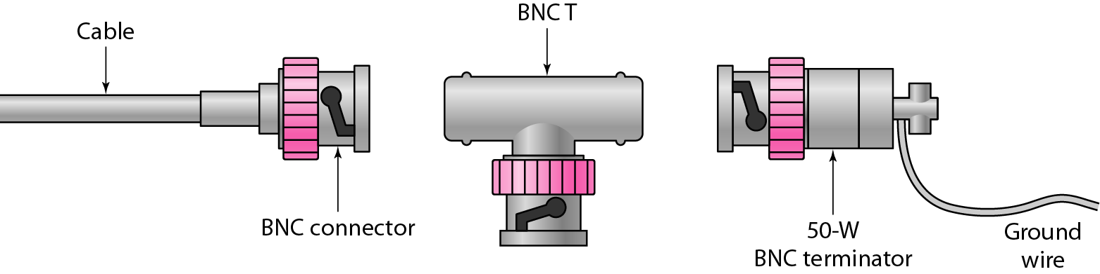



connected to the NIC card

Before Coaxial cable(electrical signal) Now, Fibre Optics (light rays)

#### **Fibre optical cable**

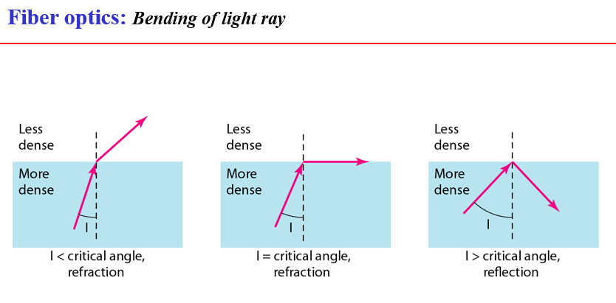

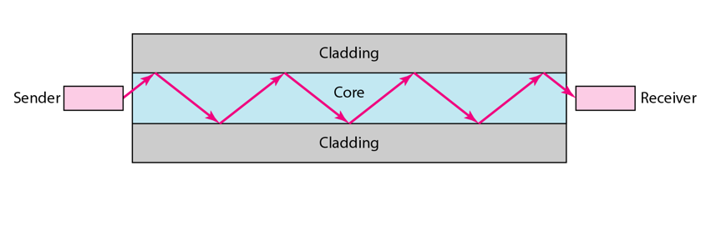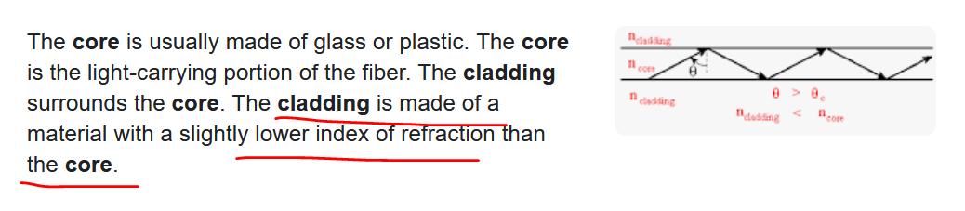

##### **Propagation mode**

Classified based on the class-material used.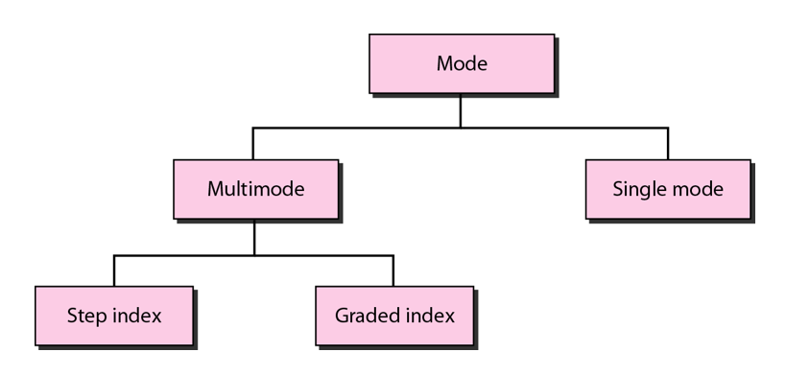

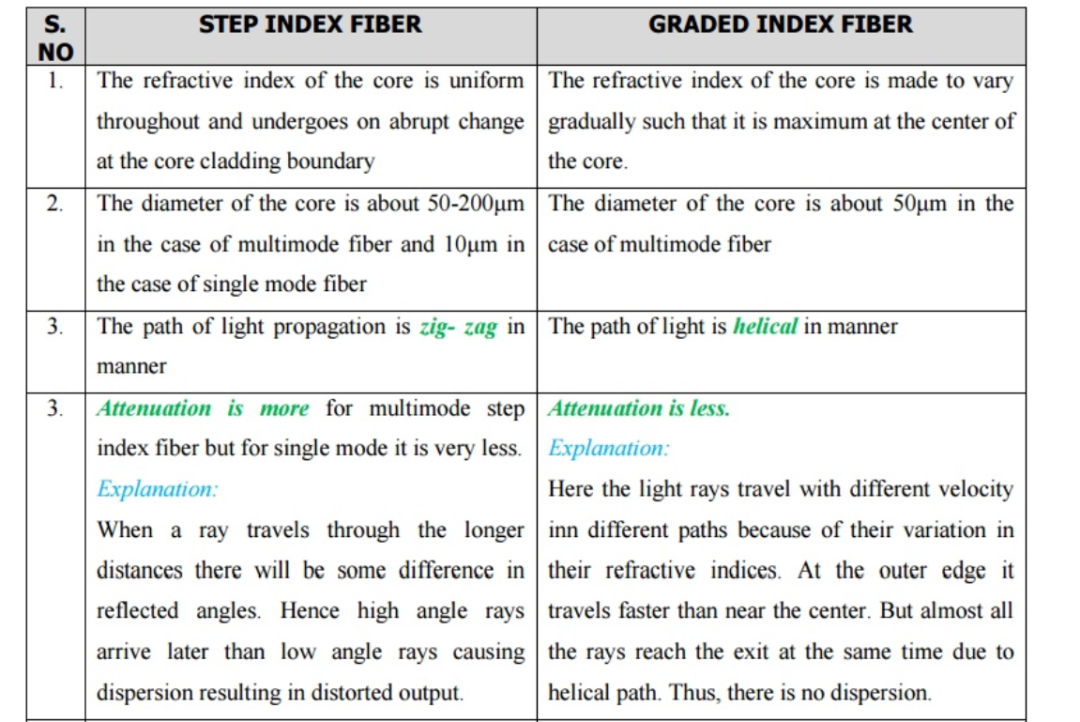

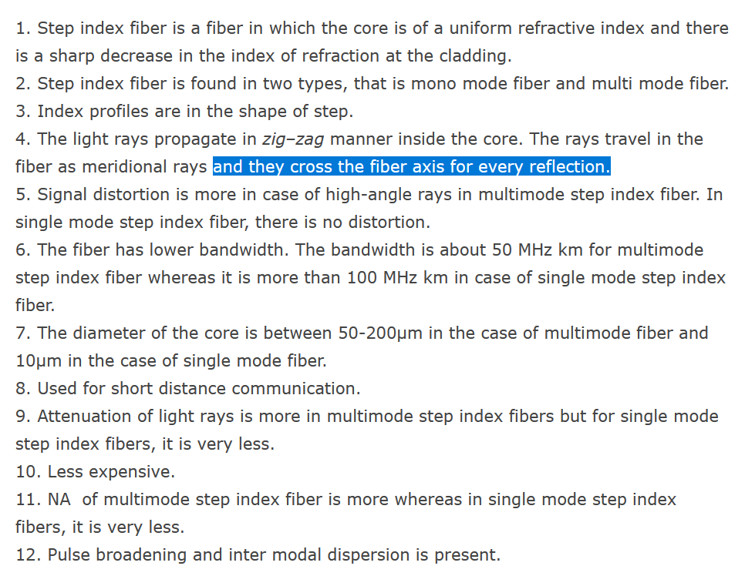



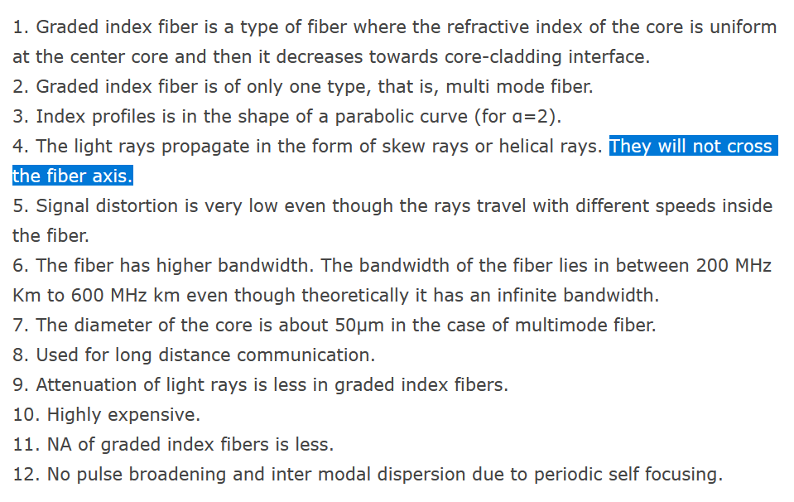



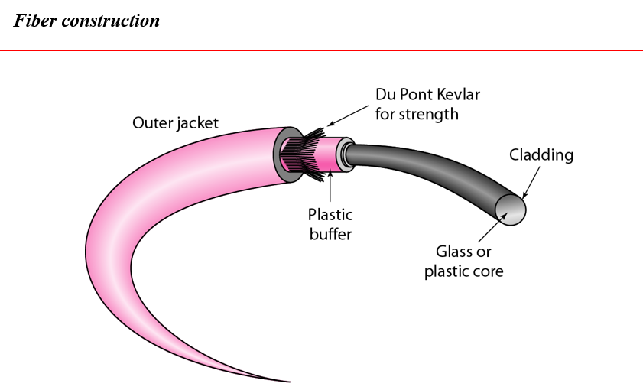

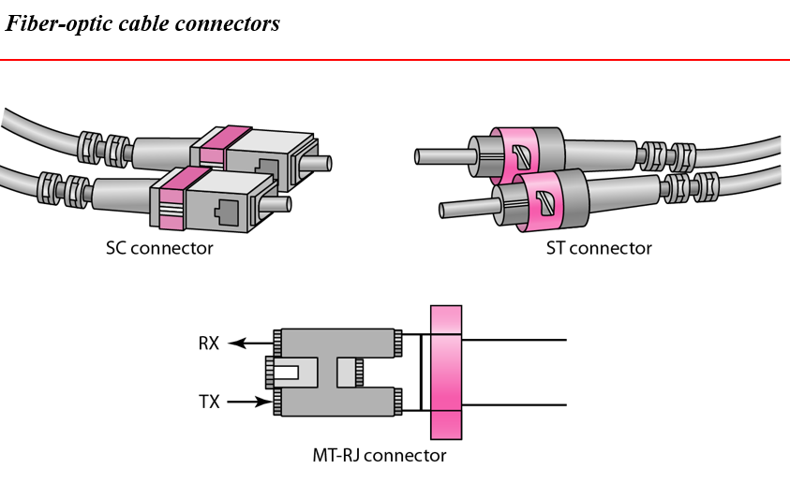

Twisted pair 🡪 UTP connector(RJ-45 male , RJ-45 female)  
Co-axial cable 🡪 BNC connector  
Fibre-optics 🡪 SC connector, ST connector, MT-RJ connector

Coaxial 🡪 Noise is in electrical form. Will also come.  
Fibre optics 🡪 Noise is in electrical which will not come in fibre optics.

### **Un-Guided Media (wire)**

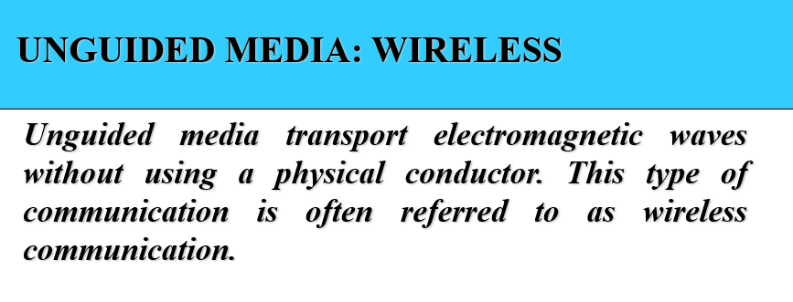

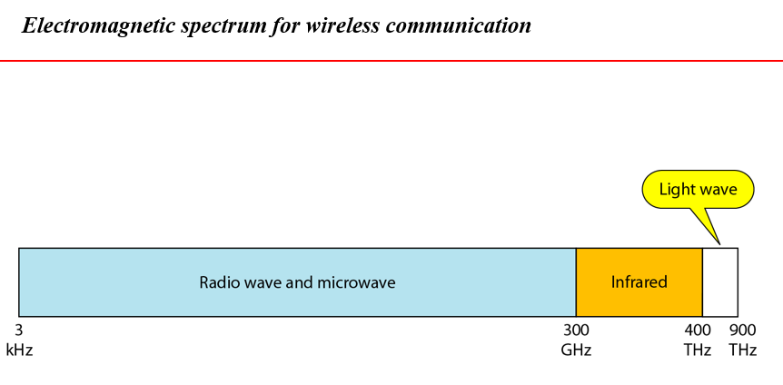

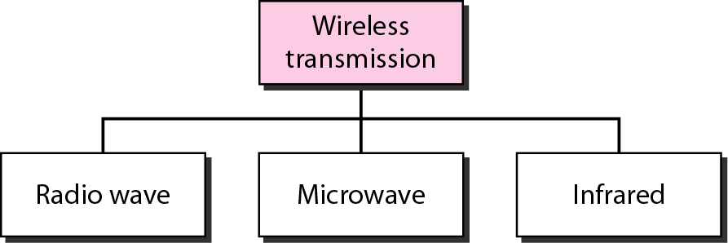

#### **Radio Waves**

Radio waves are used for multicast communications, such as radio and television, and paging systems.   
They can penetrate through walls. Highly regulated. Use omni directional antennas

#### **Microwaves**

Microwaves are used for unicast communication such as cellular telephones, satellite networks,  
and wireless LANs.  
Higher frequency ranges cannot penetrate walls.  
Use directional antennas - point to point line of sight communications.

#### **Infrared**

Infrared signals can be used for short-range communication in a closed area using line-of-sight propagation